Input the Census Block layer, named ‘block’.

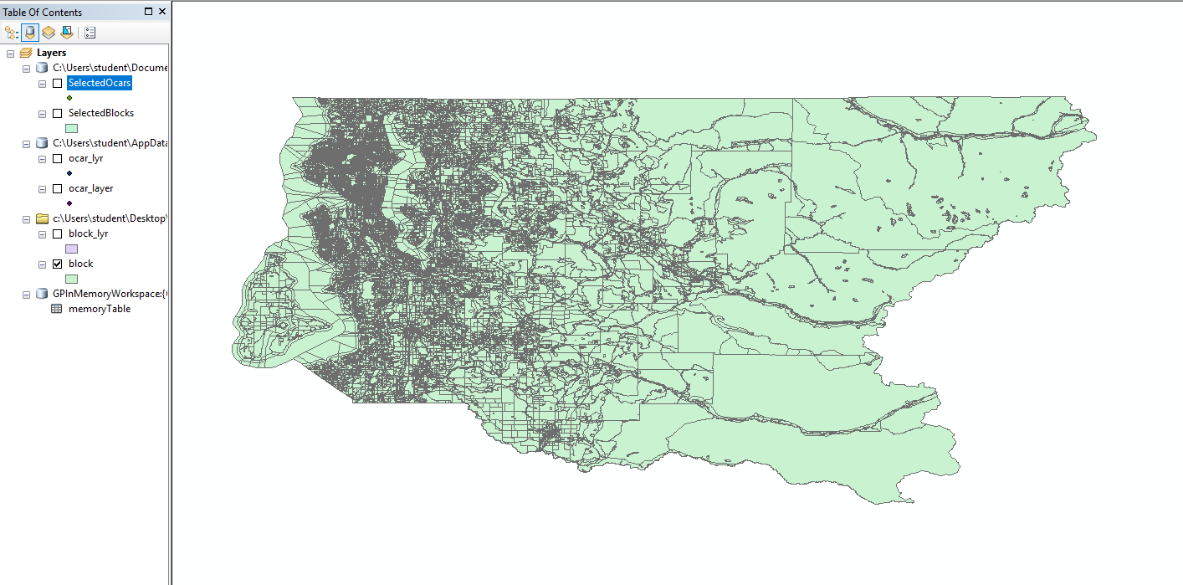

Input the Car2Go data, plot the graph based on x,y coordinates of the origins. Change the projection system to ‘GCS North American 1983’, which is the same as the Census Block.

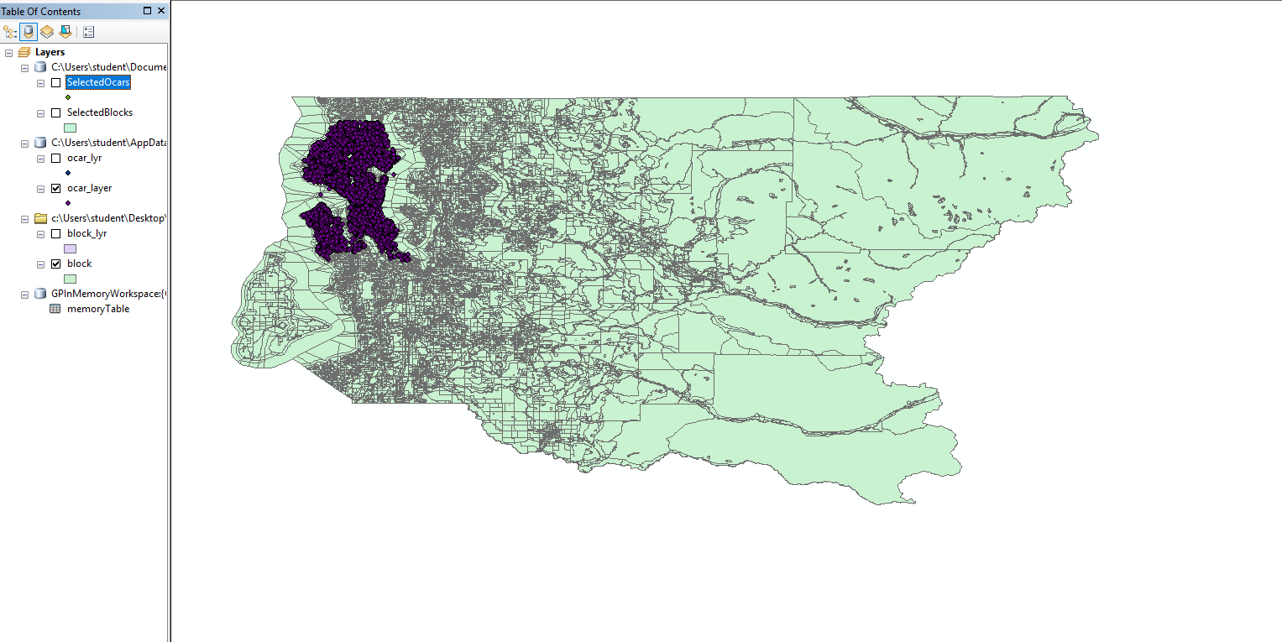

Create a temporary copy of ‘block’ and select the area which has Car2Go data.

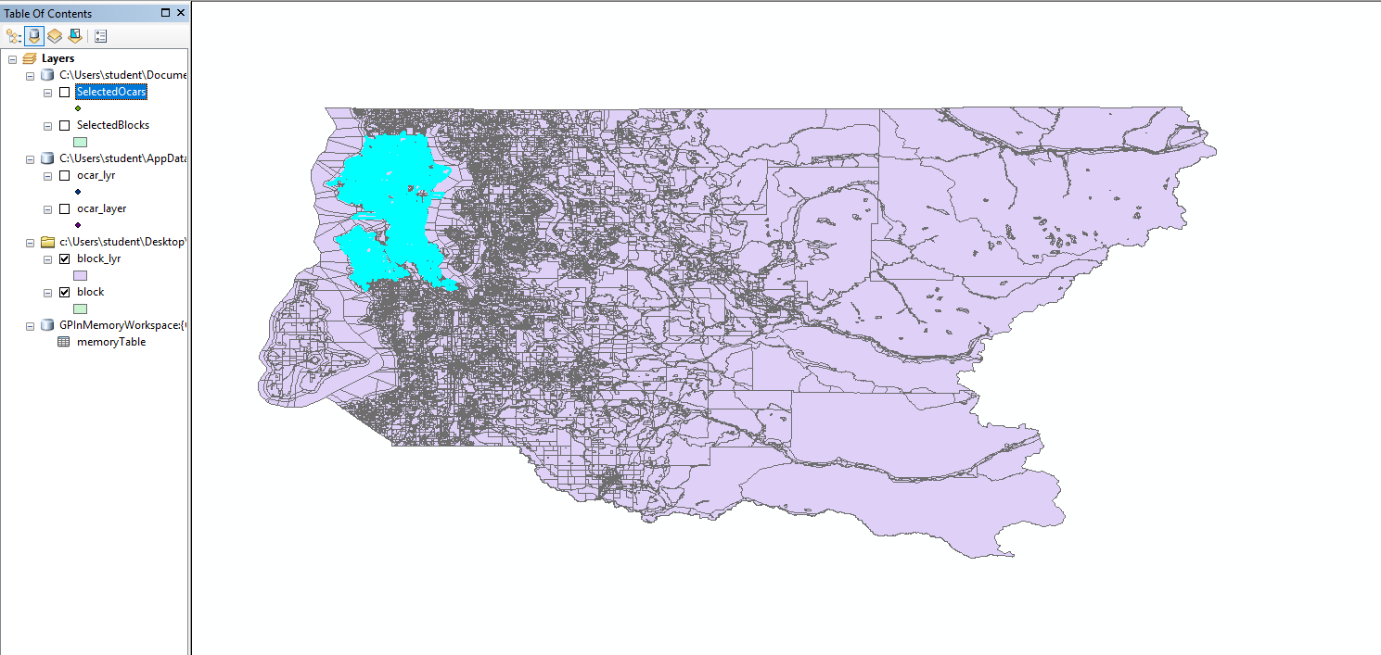

Clip the block layer. Create a new layer ‘SelectedBlocks’ by the selection.

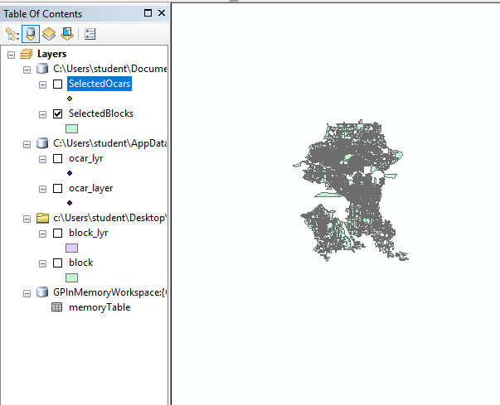

Create a temporary copy of ‘ocar_layer’. Select the points intersecting with the ‘SelectedBlocks’ area.

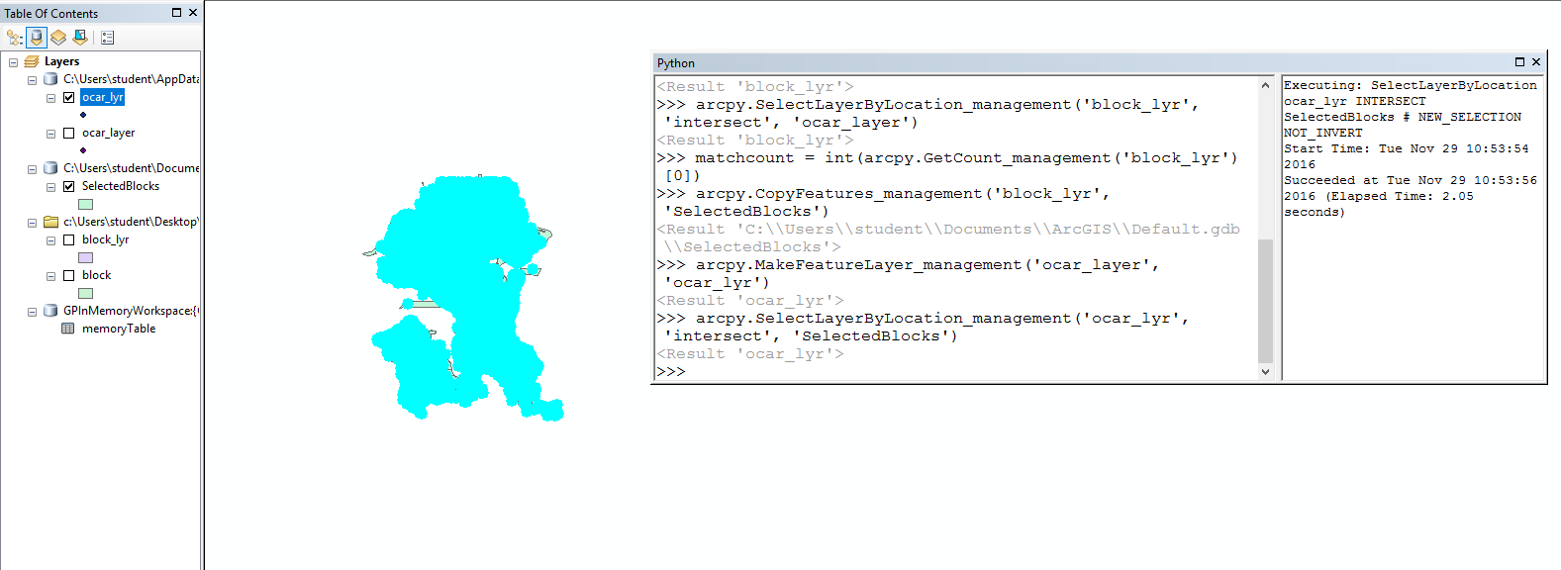

Output a new layer ‘SelectedOcars’ by the selection.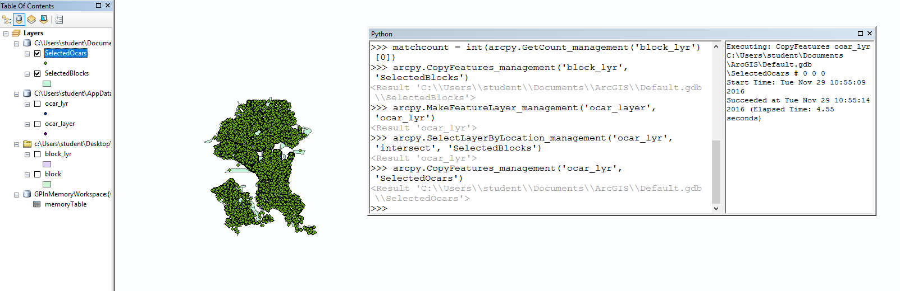

The basic steps of the code shown in Python window in ArcGIS.

